

Statistical Analysis Tool

Najla Mohammed Al-thobaiti | 445002192
Noran Abdullah Aljodi | 445005178
Rema Saed Althqfi | 445005754
Reema Salem Alharbi | 445000219

Dr. Iman Alharbi Tools and Software Development

Introduction

Github link: neunaj/ourproject

Problem Statement
Working with numeric data can be challenging when trying to extract meaningful insights. Whether in business, research, or academic settings, analyzing such data often involves computing basic statistics like mean, mode, minimum, maximum, and standard deviation. Performing these tasks manually is time-consuming, error-prone, and inefficient especially with large or unorganized data files.

Overview
This project introduces a simple, yet effective script designed to perform statistical analysis on numeric data. Users are prompted to enter the name of a file containing numeric values. The script verifies the file’s existence, cleans the data by removing invalid entries, and allows users to choose specific columns and the types of statistics they wish to compute. Available operations include calculating the mean, mode, minimum and maximum values, standard deviation, sum.

Motivation
Statistical analysis enables users to understand their data, recognize patterns, and make informed decisions. However, many users do not have access to—or prefer not to use—complex statistical software. This project provides a lightweight, accessible alternative for anyone seeking quick and straightforward numeric data analysis. It also shows how simple scripting techniques can be applied to real-world data problems efficiently.

Design and Implementation

flowchart
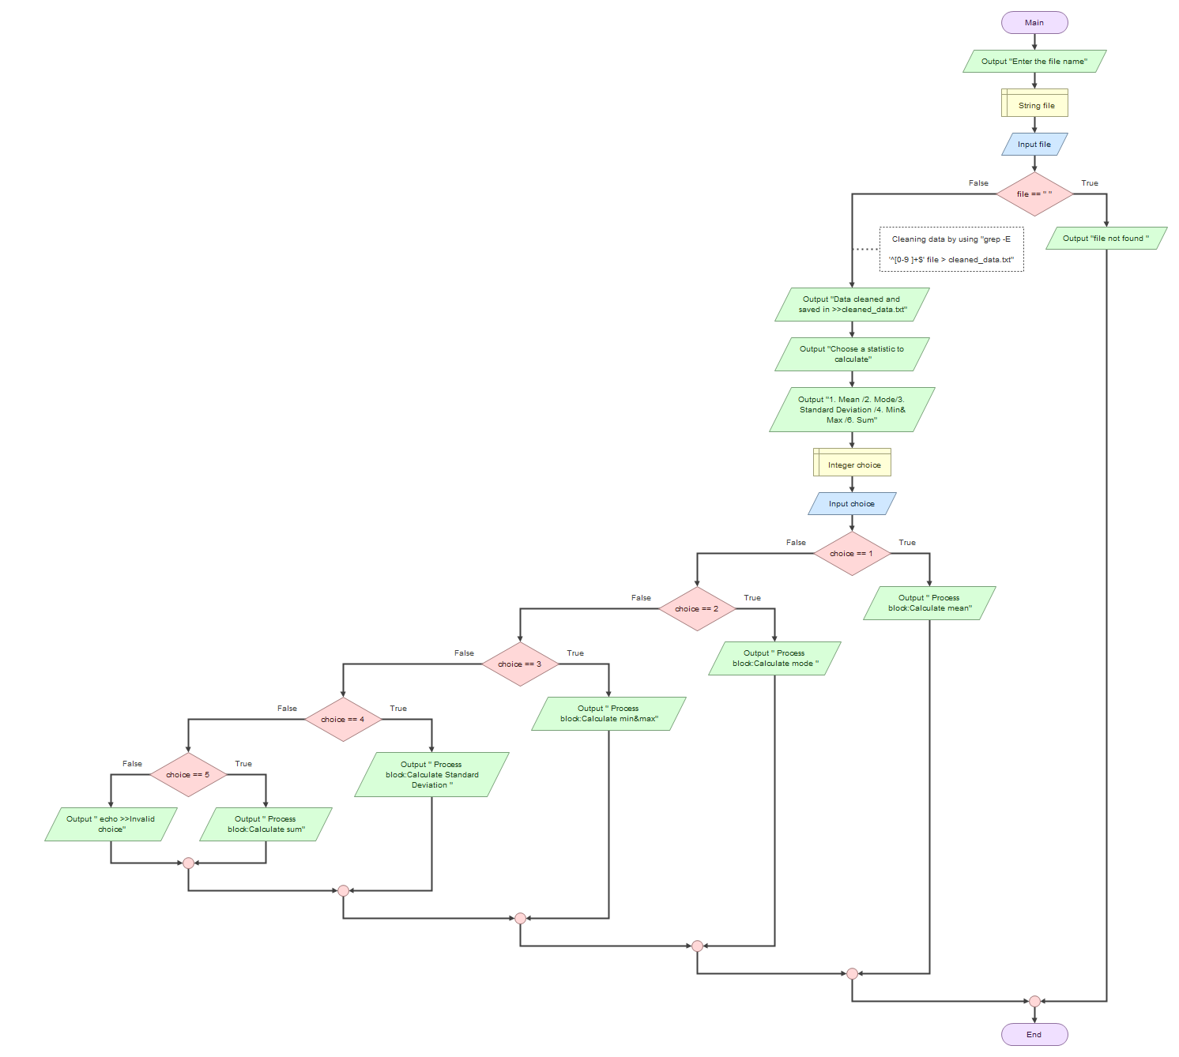

flowchart

explain the flowchart

1-Program Start: The program begins by asking the user for the name of the data file.
2-File Existence Check: It checks whether the file exists.
If the file does not exist, it displays an error message and terminates the program.
If the file exists, it cleans the data by extracting numbers only and saves them in a new file.
3-Display Statistics List: After cleaning the data, a list of possible statistics to calculate is shown to the user.
4-Operation Selection: The user enters the number of the statistic they want to calculate.
5-Calculation Execution: Based on the user's choice, the program calculates the mean, mode, standard deviation, minimum value, maximum value, or sum.
6-Choice Validation: If the choice is invalid, it displays the message "invalid choice."
7-Program End: The result is displayed, and the program terminates.

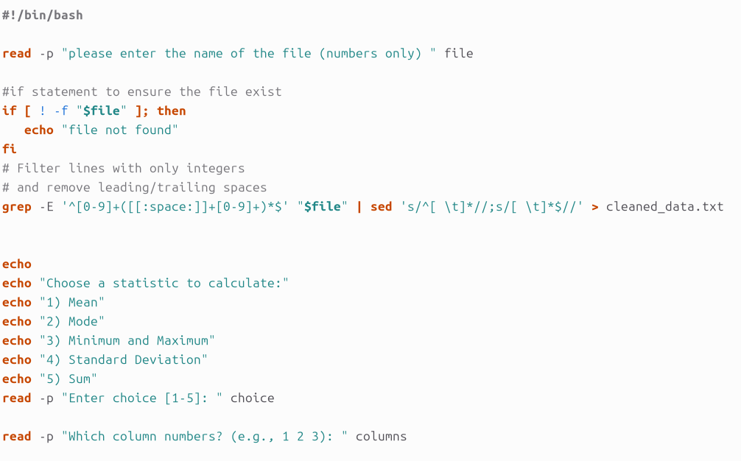

File Input & User Interaction
This part of the script focuses on getting the input file, cleaning the data, and allowing the user to choose what kind of analysis they want to perform.
Getting the File
- The script starts by asking the user to enter the name of the file that contains the numerical data.
- It then checks if the file exists. If not, it prints "file not found" and stops execution.
Cleaning the Data
- To ensure the data is usable, we used grep to filter out any lines that don’t contain just numbers (separated by spaces or tabs).
- We then used sed to remove any leading or trailing whitespace from each line.
- The cleaned data is saved into a new file called cleaned_data.txt, which is used for further analysis.
Letting the User Choose
- The script displays a list of statistical operations:
  - Mean
  - Mode
  - Minimum and Maximum
  - Standard Deviation
  - Sum
- The user picks one by typing the corresponding number.
- After that, they’re asked to enter which column(s) they want to analyze

File before cleaning: File after cleaning:
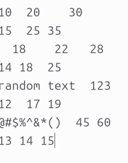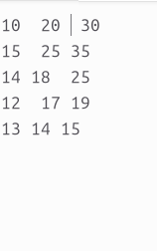

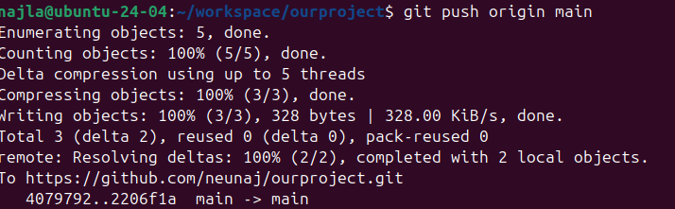

Case 1: Mean Calculation
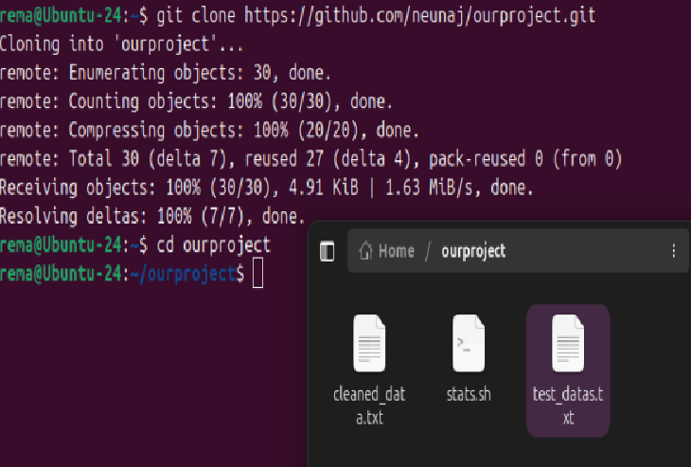

Before proceeding with code development,
The project was first downloaded from GitHub

Purpose
This part of the script runs when the user selects option 1 (Mean) from the statistics menu.
Column Selection
The script prompts the user to enter the column number they want to analyze from the cleaned data file (cleaned_data.txt).
Data Extraction
The script reads the cleaned_data.txt file line by line and extracts the numerical values from the selected column only.
Mean Computation
- The script initializes two variables: sum to zero for accumulating values.
- It reads the file line by line, extracting the value from the selected column using awk.
- Each extracted value is added to sum, and the count is increased by one to count how many values were processed.
- After reading all lines, the script calculates the mean by dividing the total sum by the count.
- To handle decimal values accurately, the division is done using awk instead of basic shell arithmetic.
- Finally, the calculated mean is displayed to the user.
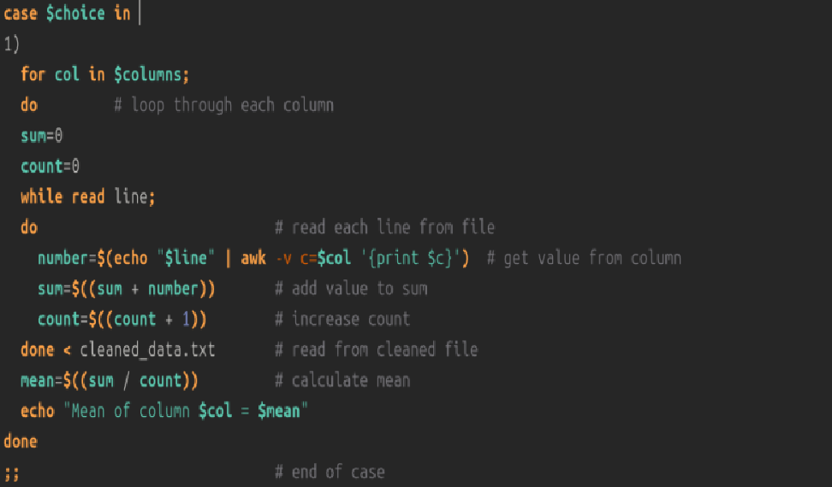

Case 1: Mean Calculation
Terminal output example:
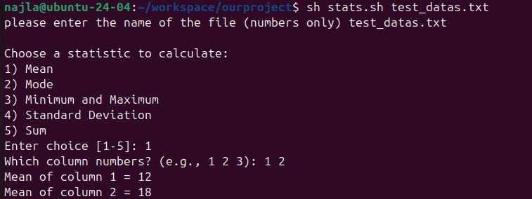

Once the modifications were made, I uploaded them to the GitHub repository by executing the git push command.


At this stage, the project has been successfully pushed to the GitHub repository.


Case 2: Mode
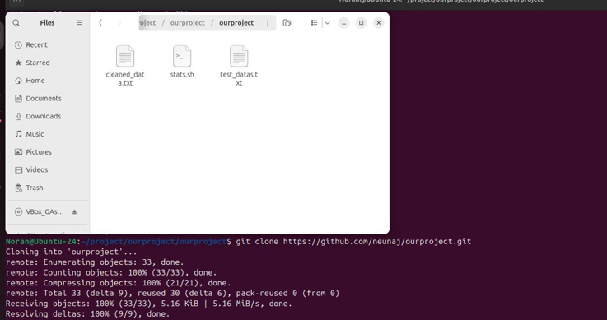
Before proceeding with code development, the project was first downloaded from GitHub
- This section of the script calculates the mode (the most frequent value) for any selected column(s) from the input file.
🔹 Purpose:
The mode is useful to identify the most commonly occurring value in a dataset, which helps in analyzing patterns or repeated data points.
- A for loop is used to iterate through each column specified in $columns.
- For each column, the script uses the (awk)command to process the data and calculate the mode.
- Inside the awk block:
- It maintains a frequency count for each value in the column using (array freq).
- It increments the count for each occurrence of a value in the column.
- After reading all values in the column:
- The script initializes variables mode to store the most frequent value and max to store the highest frequency.
- It loops through the (freq array) to find the value with the highest frequency.
- If a value's frequency is greater than the current max, it updates max and sets mode to the current value.
- Once the mode is determined for the column, the script prints the column number, the mode, and the frequency of the mode.
- The loop moves to the next column and repeats the process until all specified

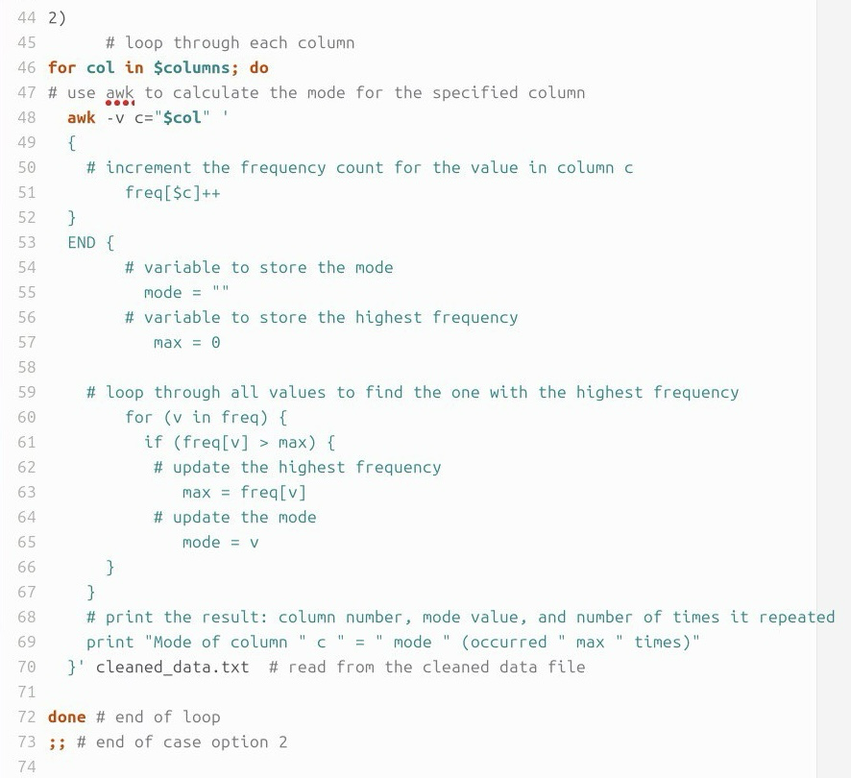
The code:

Terminal output example:
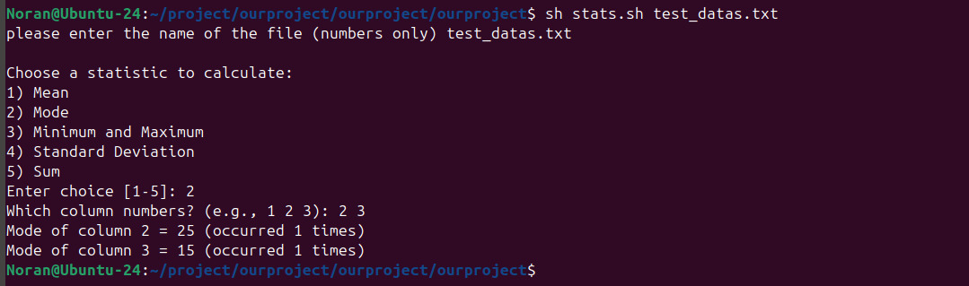

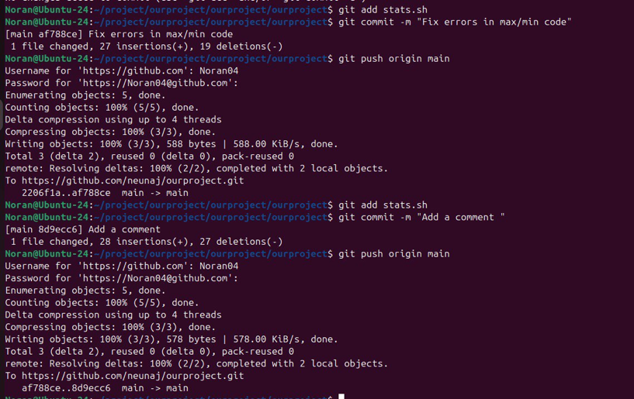
Once the modifications were made, I uploaded them to the GitHub repository by executing the git push command

At this stage, the project has been successfully pushed to the GitHub repository
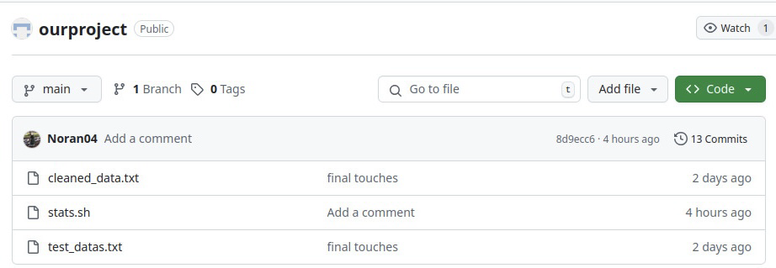

Case 3: Minimum and Maximum
- This part of the script is used to find the smallest (minimum) and largest (maximum) values in the selected column(s).
🔹 Purpose:
Finding the minimum and maximum helps understand the range of values in the data and quickly shows the lowest and highest points in a dataset.

- A for loop is used to iterate through each column specified in the $columns variable.

- For each column, the (awk) command is used to calculate the (minimum)and (maximum) values.

- Inside the awk block:
- The value of the current element in the column is retrieved and stored in the variable value.

- On reading the first row of the column (NR == 1):
- The first value is initialized as both min (the minimum value) and max (the maximum value).

- As the script continues to read through the remaining values in the column:
- The current value is compared with the stored minimum value (min).
- If the current value is smaller, (min) is updated to hold the current value.
- The current value is also compared with the stored maximum value (max).
- If the current value is larger, (max) is updated to hold the current value.

- After processing all rows in the column:
- The script prints the column number, the minimum value (min), and the maximum value (max).

- The loop proceeds to process the remaining columns until all specified columns are processed.
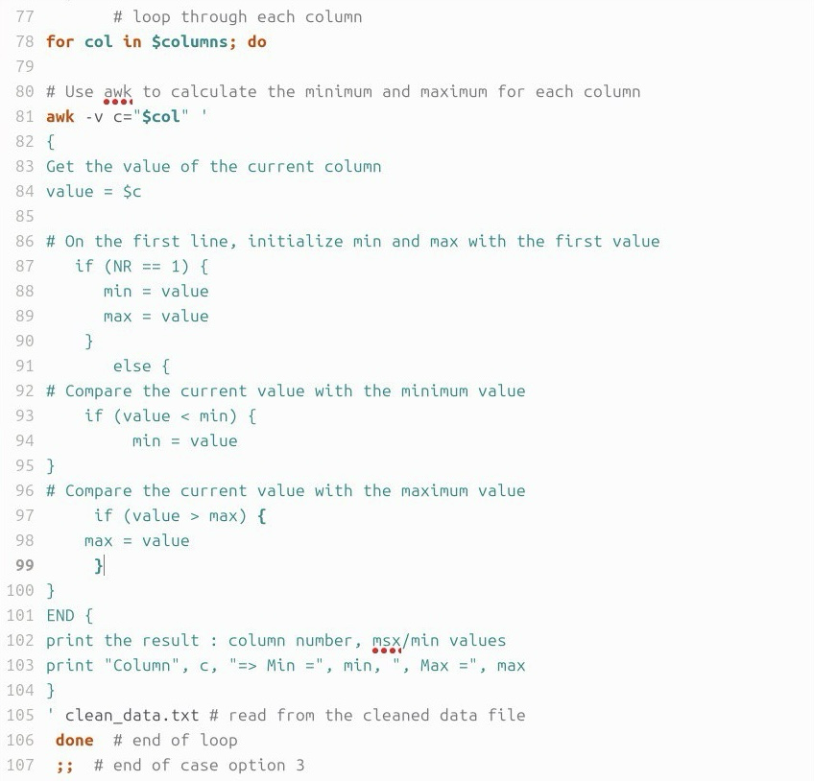
The code:


Terminal output example:

Case 4: Standard Deviation
Purpose
Executed when the user selects option 4, this section calculates the standard deviation of values in a selected column to show how spread out the numbers are.
Column Selection
- The user chooses which column to analyze from the cleaned data.
Computation Steps
- The script uses awk to loop through all rows and calculate the total sum and the sum of squares of the column values.
- It then counts the number of entries.
- Using the formula:
Standard Deviation = sqrt( (sum of squares / number of values) - (mean ^ 2) )
it calculates the standard deviation using awk's math functions.
- Finally, it prints the result rounded to two decimal places.

The code:
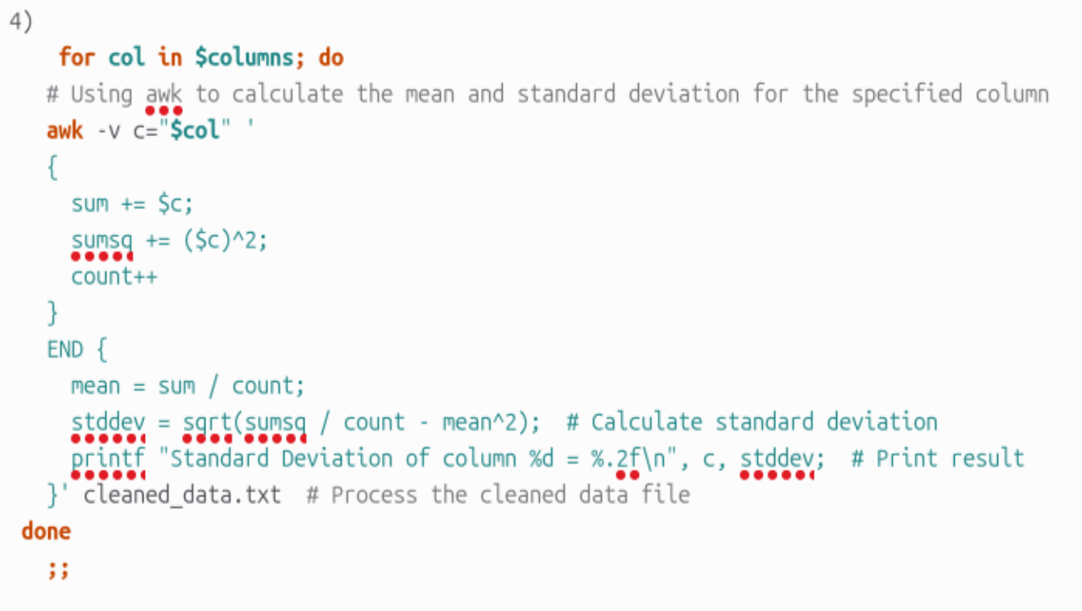

Terminal output example:

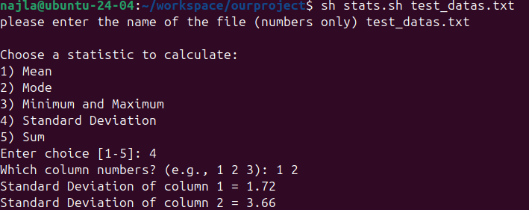

Once the modifications were made, I uploaded them to the GitHub repository by executing the git push command.
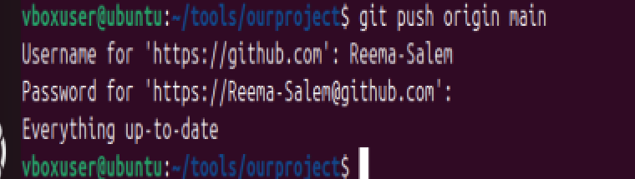

At this stage, the project has been successfully pushed to the GitHub repository.
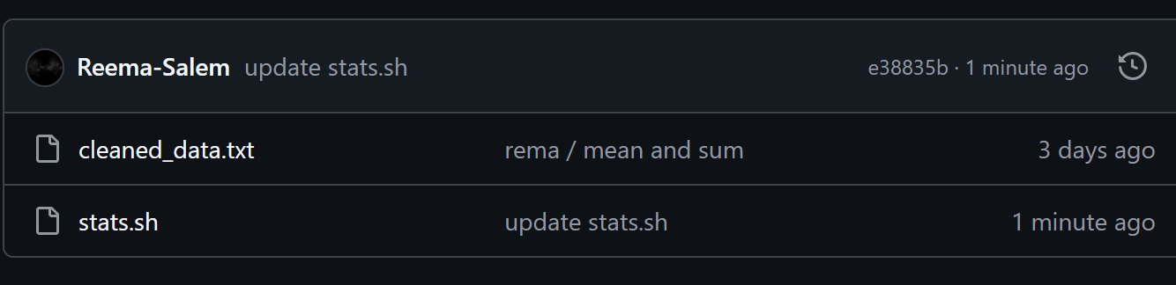

Case 5: Sum Calculation


Before proceeding with code development,
The project was first downloaded from GitHu

Purpose
This section of the script is executed when the user selects option 5 (Sum) from the statistics menu.
Column Selection
- The script prompts the user to specify which column they would like to analyze from the cleaned data.
Data Extraction
- It reads the cleaned_data.txt file and extracts all numerical values from the selected column.
Mean Computation
- The script initializes the variable sum to zero to start accumulating values.
- It reads the file line by line, extracting the selected column’s value from each line using awk.
- Each extracted value is added to the sum variable, gradually accumulating the total.
- After processing all lines, the script displays the final sum of the values in the chosen column.
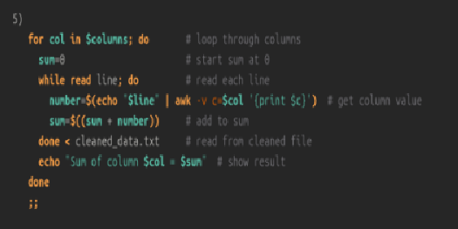

Case 5: Sum Calculation
Terminal output example:
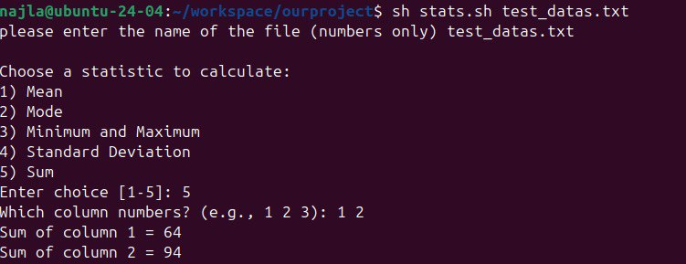

Once the modifications were made, I uploaded them to the GitHub repository by executing the git push command.


At this stage, the project has been successfully pushed to the GitHub repository.


Testing and Results
Comprehensive Testing Strategy
To ensure the script functions as intended, each feature was tested individually using numeric data in different formats.
The script was run in a Linux terminal, and all statistical options were executed one by one. The output was reviewed and compared to expected results to validate correctness.

Presentation of Results
Below are screenshots that show the execution of different statistical operations. These demonstrate that the script processes input correctly and generates the expected output.
📍 Example 1: Mean Calculation

📍 📍 Example 2: Mode Calculation
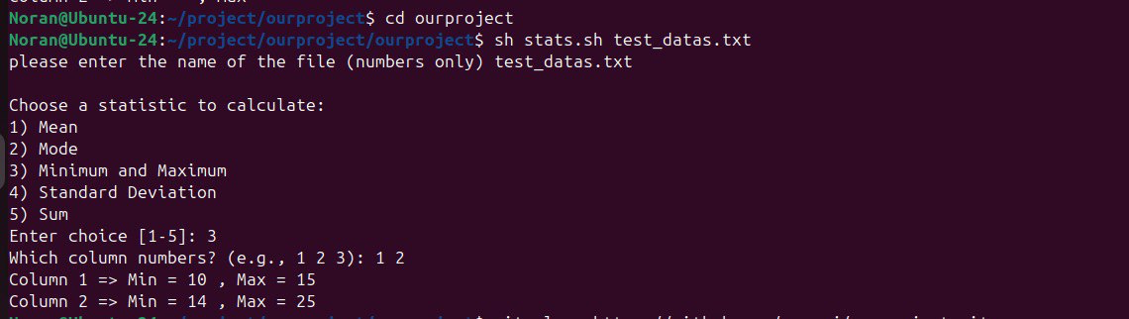
📍 Example 3: Min/Max Calculation

📍 Example 4: Standard Deviation Calculation


📍 Example 5: Sum Calculation


Analysis of Findings

The testing process confirmed that:
- The script correctly identifies and filters numeric data.
- It handles invalid input such as missing files or wrong column numbers with clear error messages.
- The statistical results (mean, mode, min, max, standard deviation, and sum) are calculated accurately for valid data.
This confirms that the tool is reliable and suitable for quick statistical analysis of numeric datasets

Conclusion

Summary of Achievements, Limitations, and Potential Future Work
Achievements
- Successfully developed a lightweight command-line tool using shell scripting to perform statistical analysis on numeric datasets.
- The tool supports essential statistical operations including Mean, Mode, Minimum and Maximum, Standard Deviation, and Sum.
- Implemented automated data cleaning using grep and sed to filter and prepare input files for analysis.
- Enabled interactive user input for selecting specific columns and desired operations.
- Project is version-controlled and hosted on GitHub for accessibility, collaboration, and future development.
Limitations
- Currently supports only plain text input files; does not handle more complex formats such as CSV with headers or Excel files.
- The tool lacks a graphical user interface, which may limit usability for non-technical users.
- Performance may degrade with very large datasets due to reliance on traditional shell commands.
- Does not currently handle missing or non-numeric values beyond basic filtering.

Potential Future Work
- Develop a graphical user interface (GUI) to enhance usability and accessibility for a broader user base.
- Extend support to additional file formats such as CSV with headers, Excel spreadsheets, and even database inputs.
- Include more advanced statistical functions such as Median, Data Distribution Analysis, and Linear Regression.
- Improve the data cleaning logic to better detect and manage missing or invalid values.
- Introduce a new Option 6 in the statistics menu that automatically performs all statistical operations for the selected column(s) and generates a comprehensive report summarizing the results in a clear and structured format.
- Consider rewriting or extending the tool using a high-level programming language such as Python for improved scalability, performance, and maintainability.

